FRONT END FULL STACK 201 - 202 -205 -206 IFMOTICA FES

***REACT TP 04* composants fonction et class props et state**

**Créer le composant class Client.js suivant**

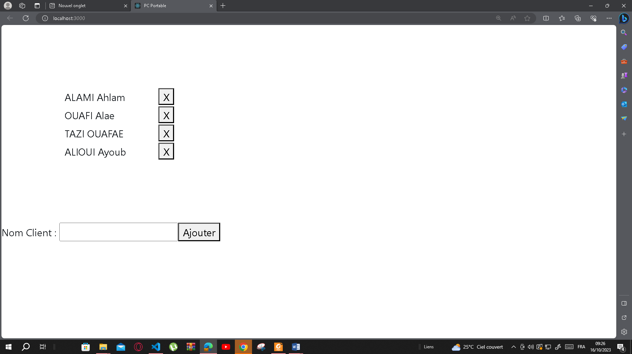

**Client.js**

import { render } from "@testing-library/react";

import React from "react";

export default class Client  extends React.Component{

 state={TClient:[{id:1,Nom:"ALAMI Ahlam"},{id:2,Nom:"OUAFI Alae"},{id:3,Nom:"TAZI OUAFAE"},

 {id:4,Nom:"ALIOUI Ayoub"}]}

 supprimer=(idsup)=>{

*this*.setState({TClient:[...*this*.state.TClient.filter((cli)=>{return cli.id!==idsup })]})

 }

 render(){

    return <>

    <table style={{margin:"100px"}}>

        { *this*.state.TClient.map((cli)=>{ return <tr><td width="150px" >{cli.Nom} </td><td><button onClick={()=>{*this*.supprimer(cli.id)}}>X</button></td></tr>})}

    </table>

    Nom Client : <input type="text"></input><button >Ajouter</button>

    </>

 }

}

**Index.js**

import React from 'react';

import ReactDOM from 'react-dom/client';

import './index.css';

import Client from './Client';

const root1 = ReactDOM.createRoot(document.getElementById('root'));

root1.render(<Client></Client>)

*// If you want to start measuring performance in your app, pass a function*

*// to log results (for example: reportWebVitals(console.log))*

*// or send to an analytics endpoint. Learn more: https://bit.ly/CRA-vitals*